**Weekly Status Update for Mid-break 2**

**Timeline:** From 10-04-2024 to 17-04-2024

**What we have done:**

Backend

* Create function for getting all the data of a single, existing NFT request to the frontend layer Songxuan

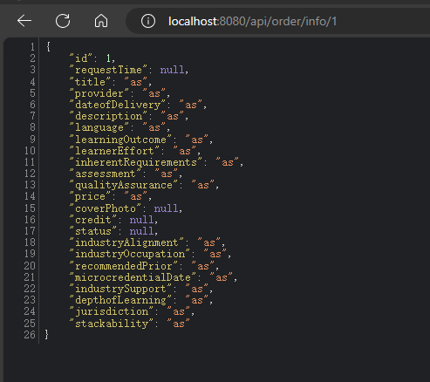

* Send email function Nuoxi
* 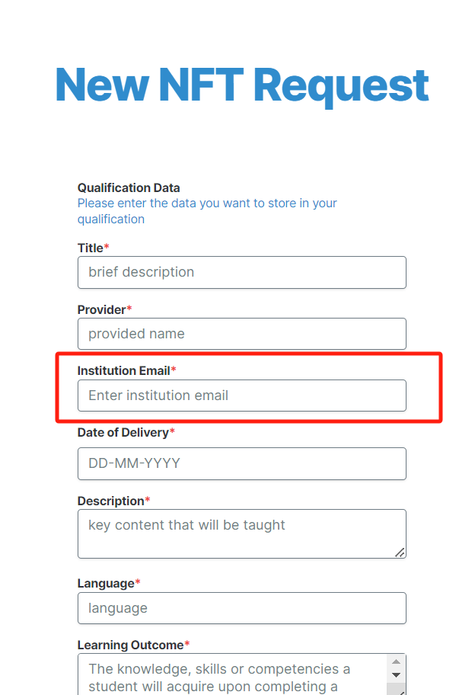
* 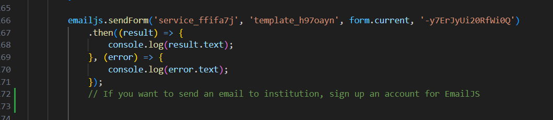
* 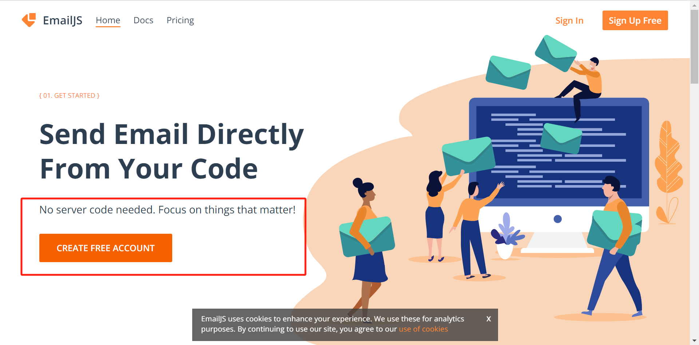

Frontend

* Build initial front end of Institution 'admin' page Andy
* [The admin board need displays the returned data](https://github.com/perspicacious-slinki/Immutable2024s1ANUTechlauncher/issues/185) Bohong

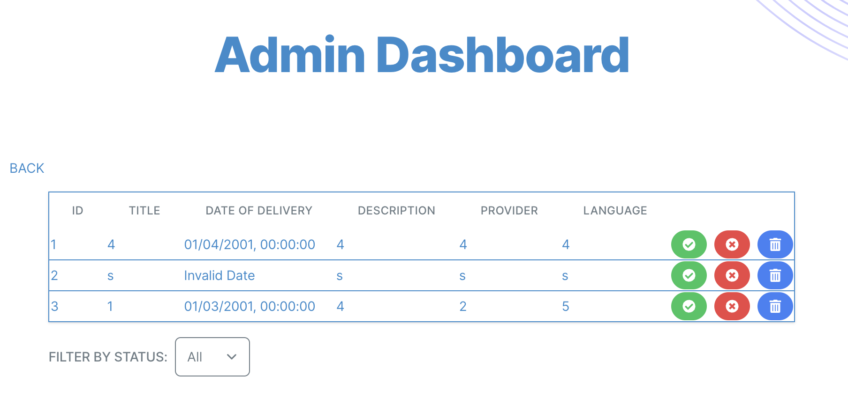

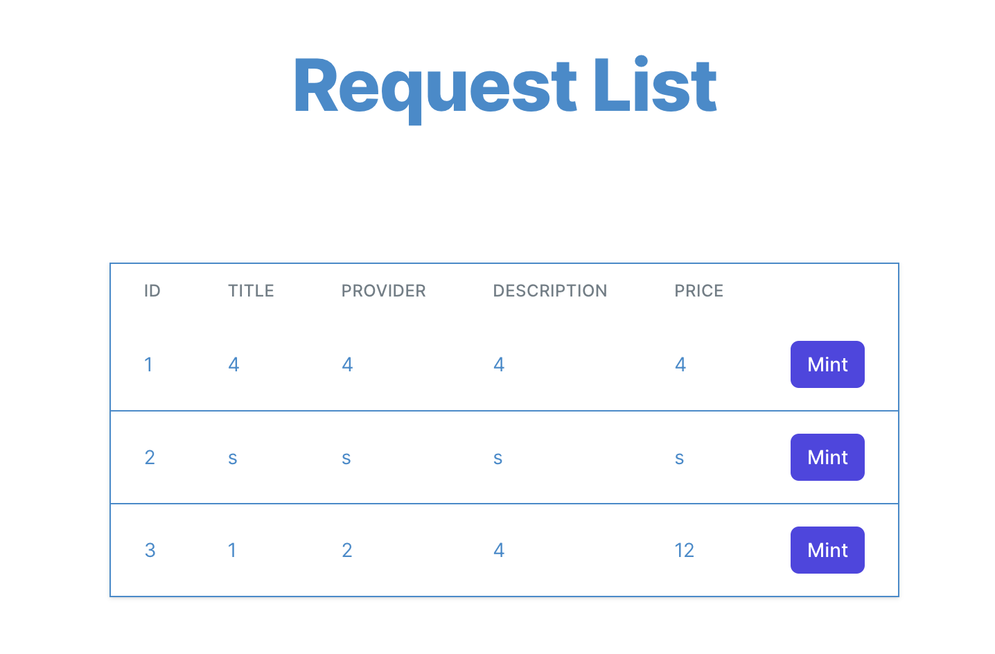

* Change the company logo in frontend website Linxi

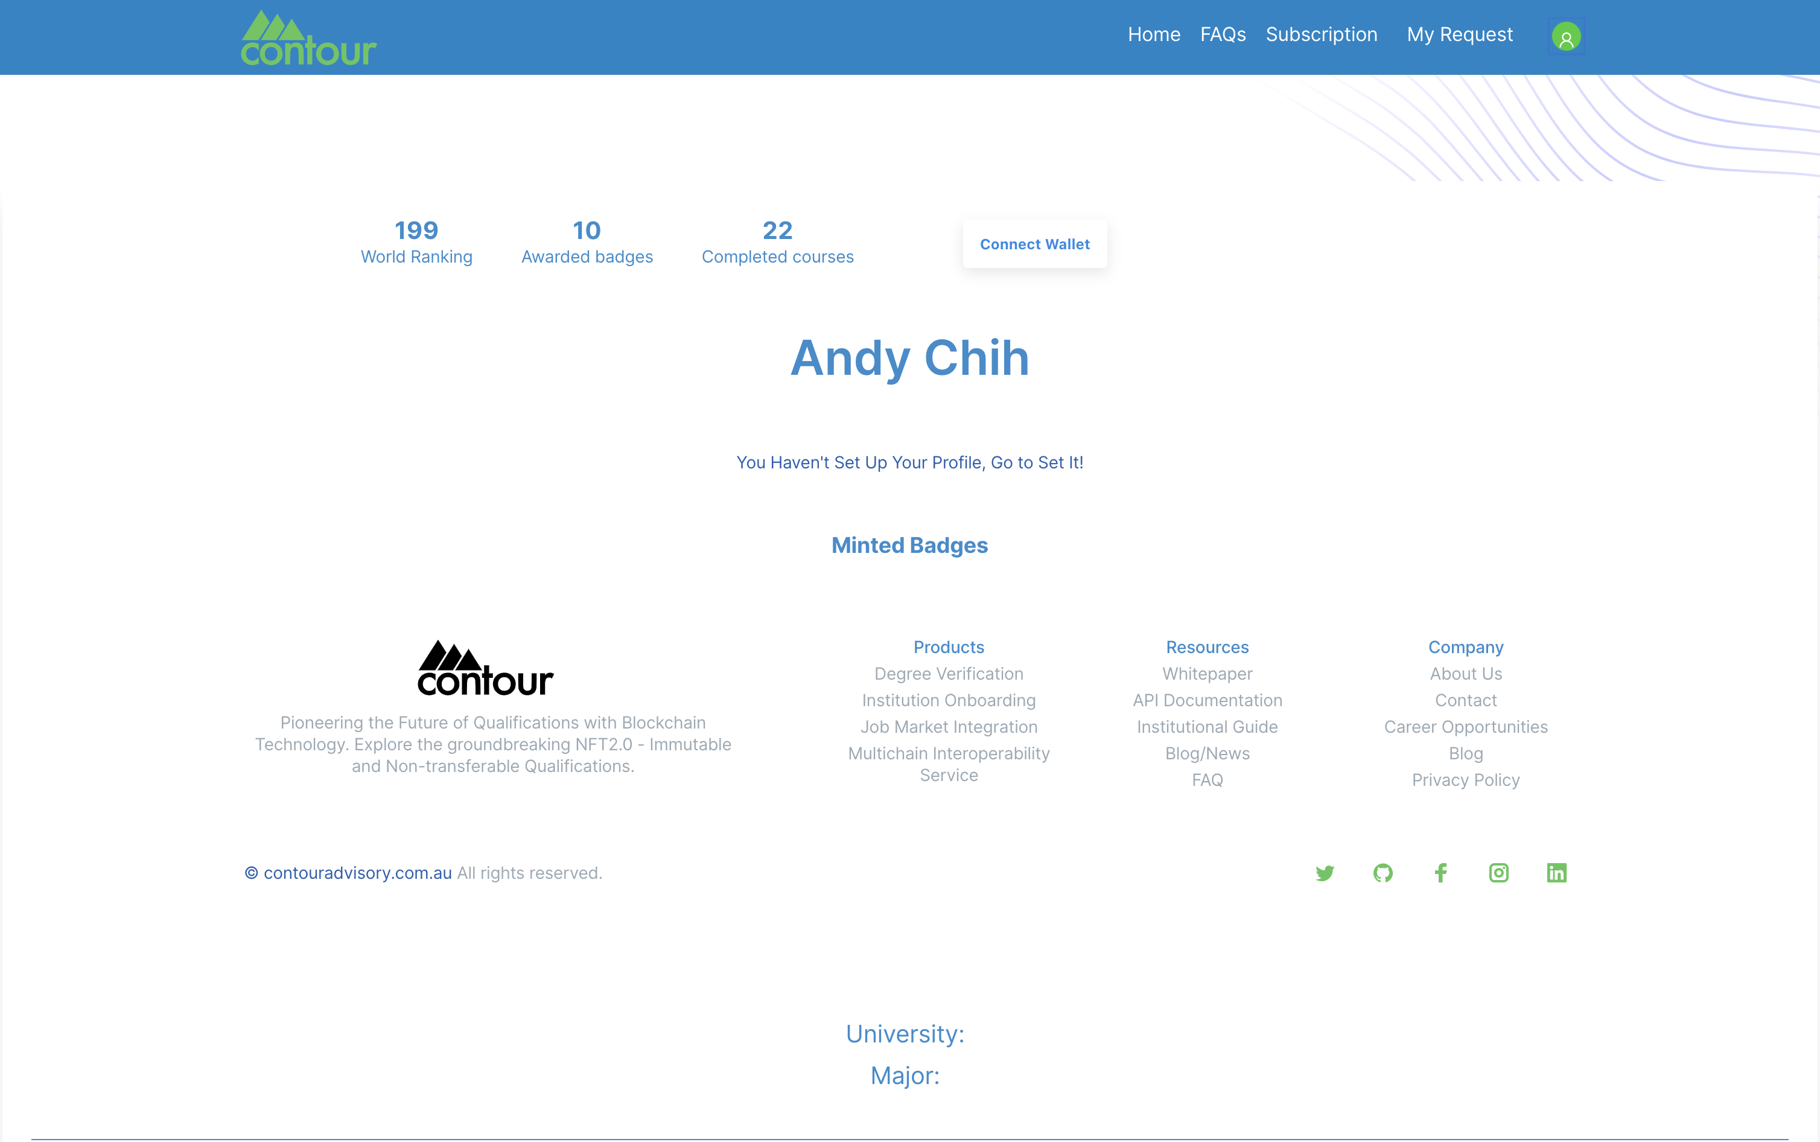

**This week plan for backend and frontend:**

|  |  |
| --- | --- |
| Request field edit in Institution Request admin page | Linxi |
| Build initial front end of Institution 'admin' page | Andy Bohong |
| Enable backend to return request information classified by institution | Songxuan |
| Configue email information of backend | Nuoxi |